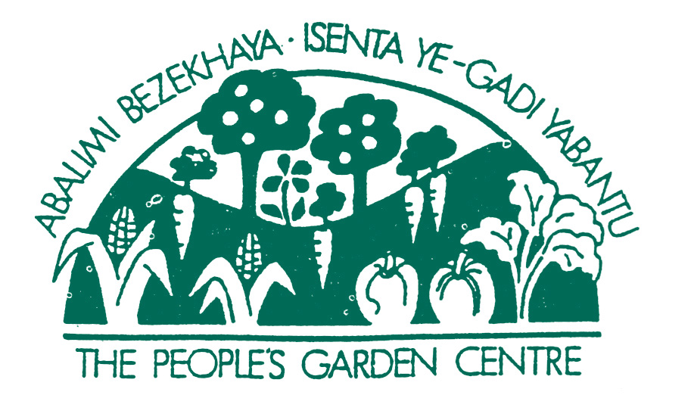

P.O. Box 44, Observatory, 7935
Tel/Fax: (021) 371 1653
Email: info@abalimi.org.za

Website: www.abalimi.org.za

015-337 NPO

VAT No. 474 020 6794
W/Cape Suppliers Database No: ABAL001TRW

March 2007

Dear Friends

Your donations via Global Giving

I know you may already have received thanks from Global Giving, but I just wanted to also say a huge thank you for your donations to our urban gardening training efforts here in the sub-economic townships of Cape Town.

You, some of you anonymous donors, have donated US $ 1641 via Global Giving to Abalimi to date. This will help us train quite a few new urban farmers, mostly women, who are very poor and who are supporting whole families, often single-handedly, from the proceeeds of their micro-farming efforts and perhaps a small government grant.

I am sure you must have already visited our web-site, but for those of you who have given us your postal addresses via Global Giving , please do look out for your hard copy Friends newsletters from us in the mail. This will probably arrive in your hands by September/October and it will be posted on our website by June/July. We never send junk mail or spam, nor guilt insipiring heart rendering appeals- just the Friends newsletters once or twice a year.

I hope you dont mind me thanking all you via one letter, but it seems like a nice thing to do, as you must all be special people to like the sort of work that Abalimi does here in the townships of Cape Town.

Please be sure to let us know when you come to Cape Town so we can show you around the projects!

All the best

Yours truly,

Rob Small

Abalimi


Abalimi collaborates with and is recognised by Ashoka, the international association of leading social entrepreneurs

